Acidity

* The hydroxyl hydrogen is the most acidic proton on a carboxylic acid
* However, in 1,3-dicarbonyls, the α-hydrogen is also quite acidic

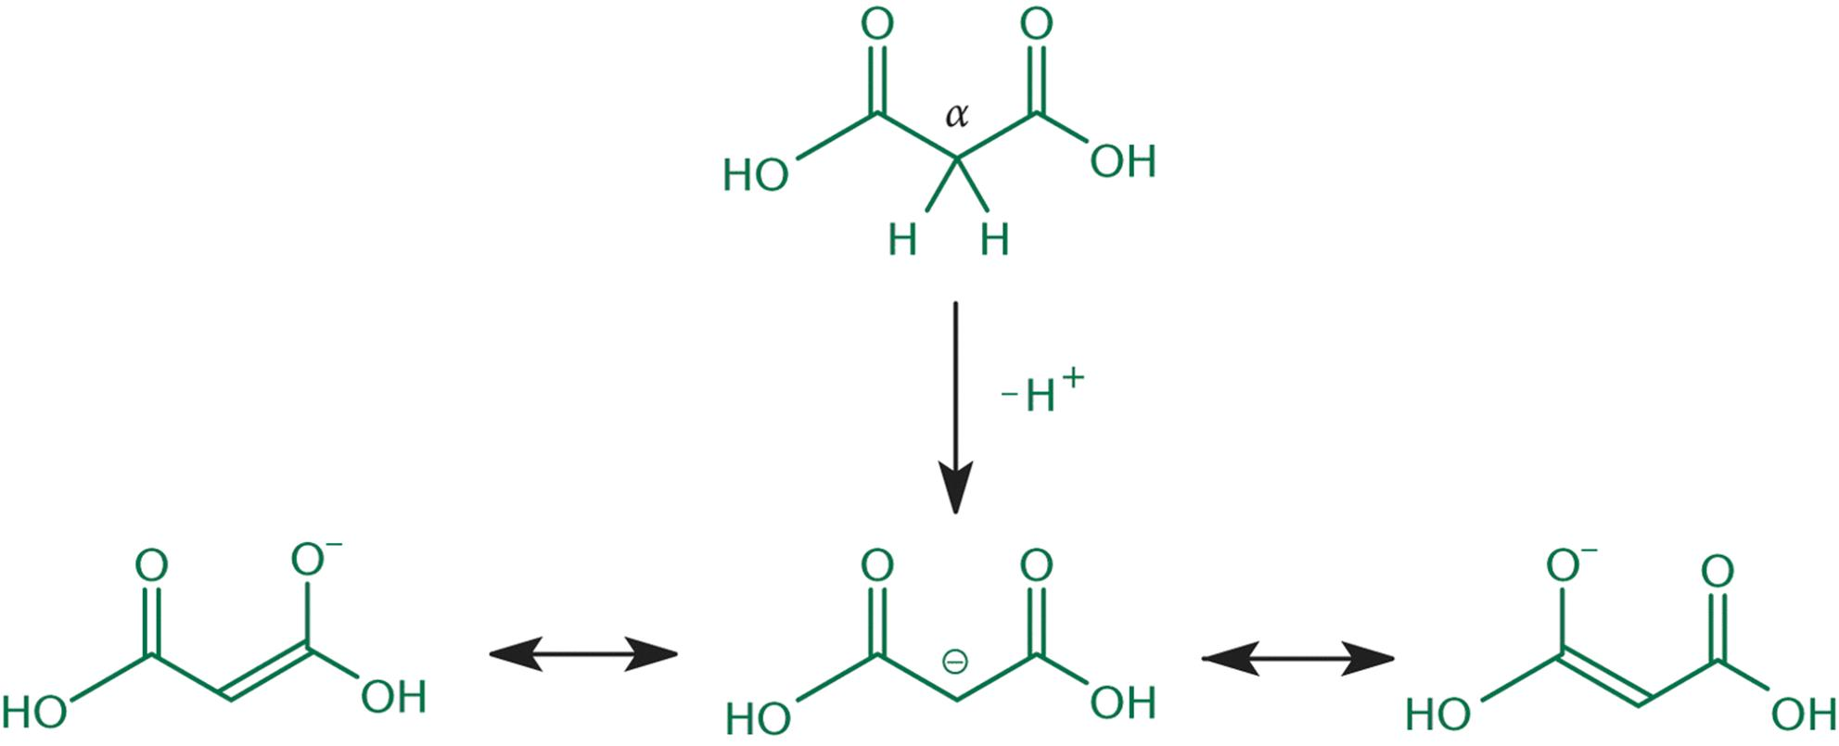

(Acidity of the α-hydrogen in β-dicarboxylic acids)

* Dicarboxylic acid >> Monocarboxylic acid >> Deprotonated dicarboxylic acid
  + A dicarboxylic acid is the most acidic as the second carboxyl group is electron-withdrawing and therefore contributes to an even higher stability of the anion after loss of the first hydrogen
  + Monocarboxylic acid is more acidic than a deprotonated carboxylic acid because the carboxylate ion is electron-donating and destabilizes the product of the second deprotonation step, resulting in decreased acidity

Synthesis of Carboxylic Acids

* Can be prepared via oxidation of aldehydes and primary alcohols

Nucleophilic Acyl Substitution

* Steps

1. Nucleophilic addition
2. Elimination of the leaving group and reformation of the carbonyl

* Note:
  + Basic solution makes the nucleophile more nucleophilic
  + Acidic solution makes the electrophile more electrophilic (and a better leaving group)

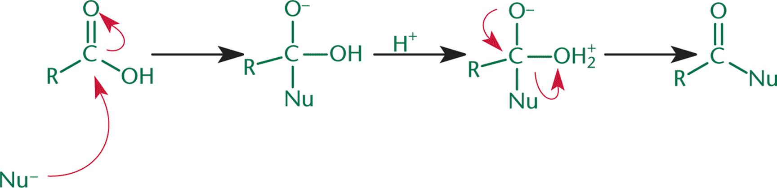

Amides

* Amides that are cyclic are called lactams

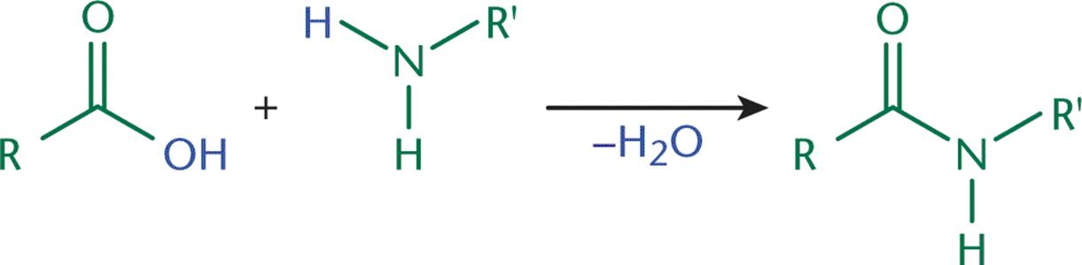

(Formation of an Amide by Nucleophilic Acyl Substitution)

Esters

* Esters that are cyclic are called lactones
* Can be made by reacting carboxylic acids with alcohols under acidic conditions → produces water as a side product (it is a condensation reaction)

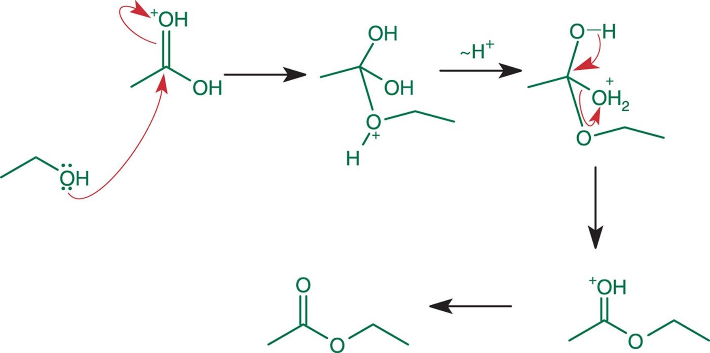

(Esterification: Reaction of a Carboxylic acid with an Alcohol)

Anhydride

* Can be formed by the condensation of two carboxylic acids

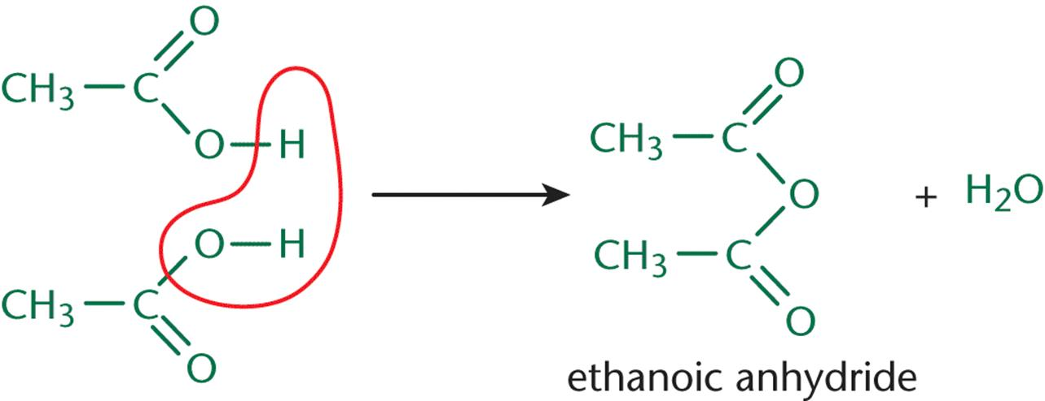

(Synthesis of Anhydride via Carboxylic Acid Condensation, which also occurs through nucleophilic acyl substitution)

Reduction

* Carboxylic acids can be reduced by LiAlH4, but **not** the less reactive NaBH4

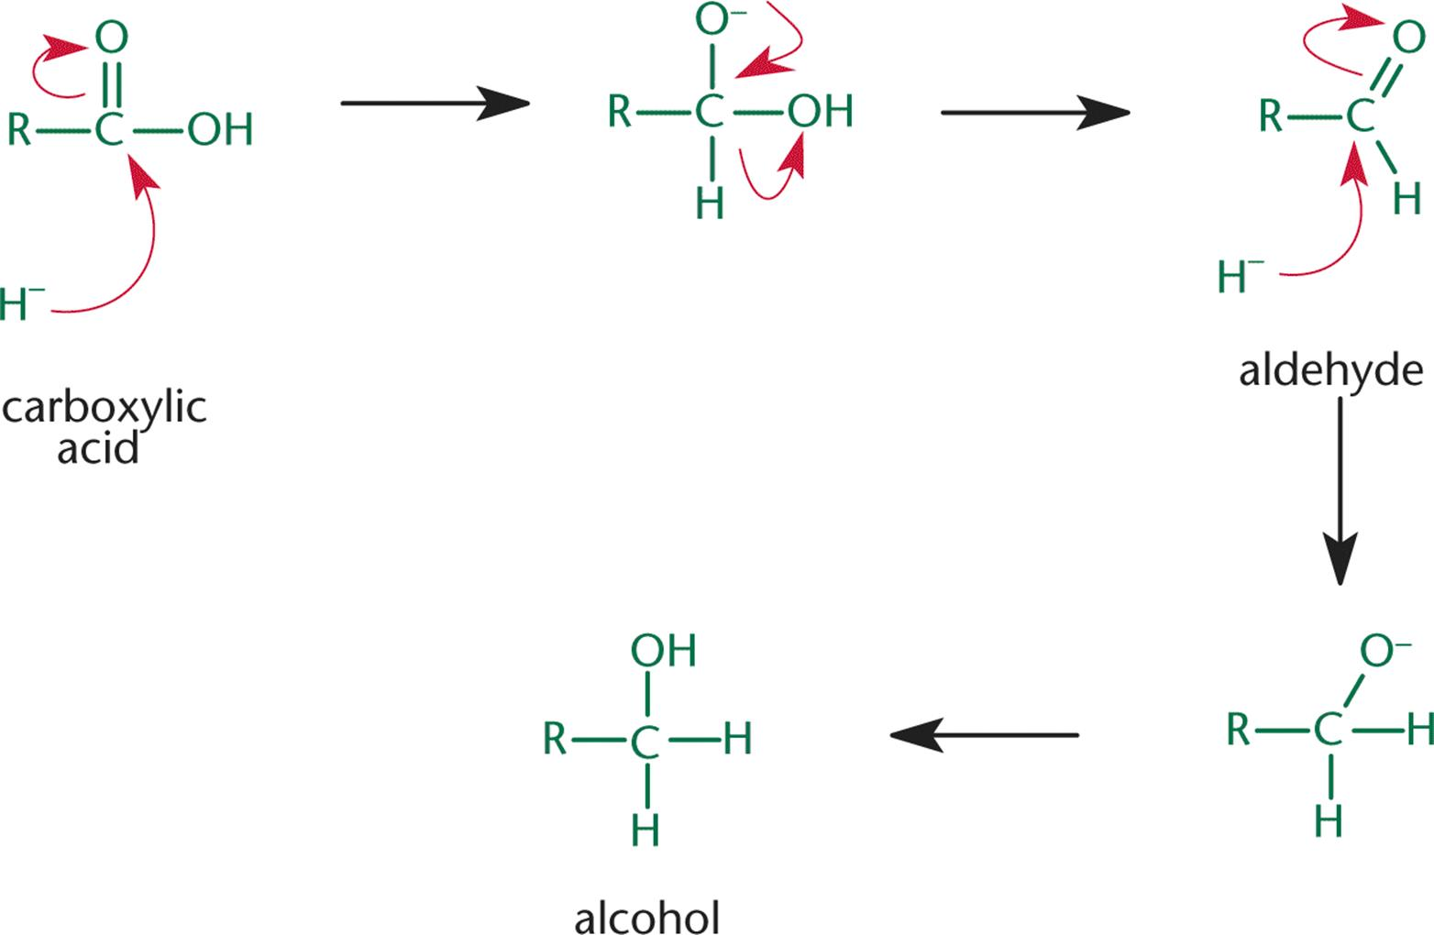

(Carboxylic Acid → Aldehyde → Primary alcohol)

Decarboxylation

* Complete loss of the carbonyl group as carbon dioxide, when **heated**
* Occurs with **β-keto acids and β-dicarboxylic acids** because they can form a cyclic transition state that permits simultaneous hydrogen transfer and loss of carbon dioxide
  + Both the electrophile and nucleophile are in the same molecule

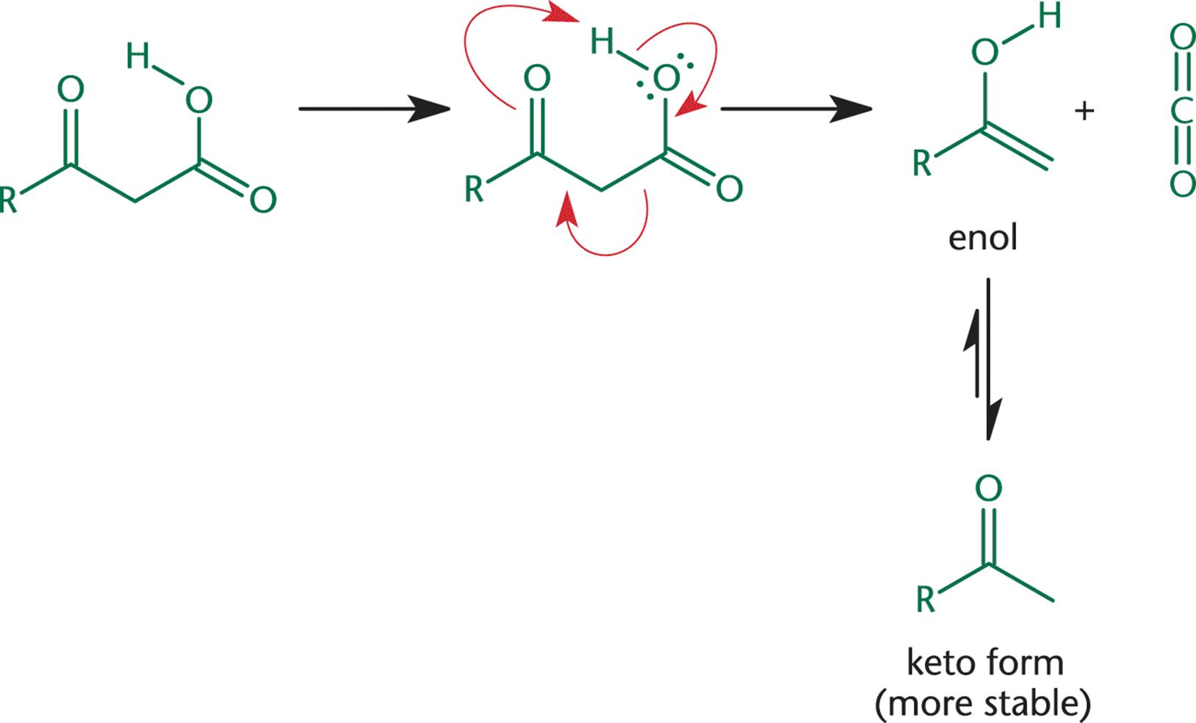

(Decarboxylation of carboxylic acids; product can tautomerize too)

Saponification

* Long-chained carboxylic acids react with sodium or potassium hydroxide to form a salt i.e. soap
  + The soap molecules can arrange themselves into micelles

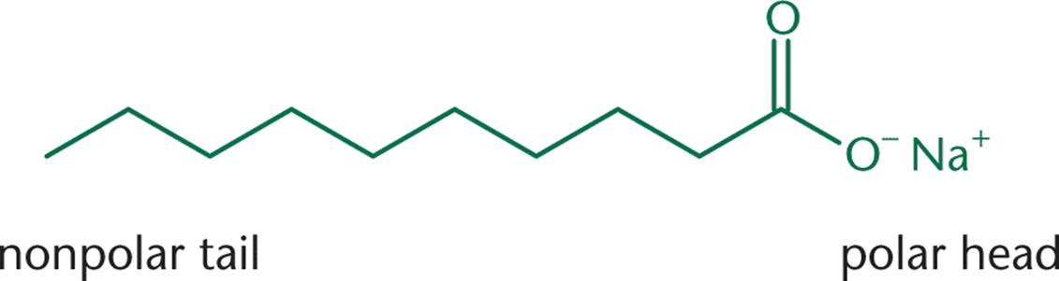

(Carboxylic acid salt (soap))